Atlantic Bolt stocks various sizes of turnbuckle bodies for use in rod assemblies for construction. We can also get other turnbuckle configurations, such as, eye and eye turnbuckles, eye and jaw turnbuckles, etc. If you don't see it here, contact us.
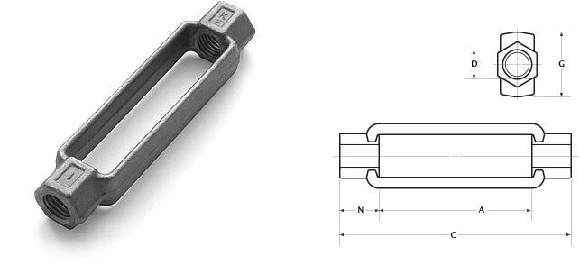

Atlantic Bolt, Inc. - turnbuckles
 | questions?
 | sales@atlanticboltinc.com
back to products
 | We make sag rod!
Item number | Description
TB037G | 3/8 X 6 TURNBUCKLE HDG
TB037P | 3/8 X 6 TURNBUCKLE
TB050G | 1/2 X 6 TURNBUCKLE HDG
TB050P | 1/2 X 6 TURNBUCKLE
TB062G | 5/8 X 6 TURNBUCKLE HDG
TB062P | 5/8 X 6 TURNBUCKLE
TB075G | 3/4 X 6 TURNBUCKLE HDG
TB075P | 3/4 X 6 TURNBUCKLE PLAIN
TB087G | 7/8 X 6 TURNBUCKLE HDG
TB087P | 7/8 X 6 TURNBUCKLE
TB100G | 1 X 6 TURNBUCKLE HDG
TB100P | 1 X 6 TURNBUCKLE PLAIN
TB112G | 1 1/8 X 6 TURNBUCKLE HDG
TB112P | 1 1/8 X 6 TURNBUCKLE
TB125G | 1 1/4 X 6 TURNBUCKLE HDG
TB125P | 1 1/4 X 6 TURNBUCKLE
TB137G | 1 3/8 X 6 TURNBUCKLE HDG
TB137P | 1 3/8 X 6 TURNBUCKLE
TB150G | 1 1/2 X 6 TURNBUCKLE HDG
TB150P | 1 1/2 X 6 TURNBUCKLE
TB175G | 1 3/4 X 6 TURNBUCKLE HDG
TB175P | 1 3/4 X 6 TURNBUCKLE
TB200G | 2 X 6 TURNBUCKLE HDG
TB200P | 2 X 6 TURNBUCKLE
<img src="http://www.webtraxs.com/webtraxs.php?id=atlanticboltinc&st=img" alt="">
Atlantic Bolt, Inc.
4112 Pine Grove Circle
Charlotte, NC 28206
704-597-5082
704-597-1741 fax

