Timber bolts are available in various sizes from Atlantic Bolt. Contact us for more information.
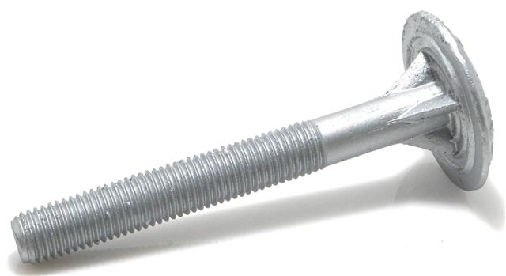

 | Atlantic Bolt, Inc - Timber bolts
 |  | back to products page
 | questions? email us
 | Item number | Description
 | TB0620600G | 5/8 X 6 TIMBER BOLT GALVANIZED
 | TB0620800G | 5/8 X 8 TIMBER BOLT GALVANIZED
 | TB0621000G | 5/8 X 10 TIMBER BOLT GALVANIZED
 | TB0621200G | 5/8 X 12 TIMBER BOLT GALVANIZED
 | TB0621400G | 5/8 X 14 TIMBER BOLT GALVANIZED
 | TB0621600G | 5/8 X 16 TIMBER BOLT GALVANIZED
 | TB0621800G | 5/8 X 18 TIMBER BOLT GALVANIZED
 | TB0622000G | 5/8 X 20 TIMBER BOLT GALVANIZED
 | TB0622200G | 5/8 X 22 TIMBER BOLT GALVANIZED
 | TB0622400G | 5/8 X 24 TIMBER BOLT GALVANIZED
 | TB0751200G | 3/4 X 12 TIMBER BOLT GALVANIZED
 | TB0751400G | 3/4 X 14 TIMBER BOLT GALVANIZED
 | TB0751600G | 3/4 X 16 TIMBER BOLT GALVANIZED
 | TB0751800G | 3/4 X 18 TIMBER BOLT GALVANIZED
 | TB0752000G | 3/4 X 20 TIMBER BOLT GALVANIZED
 | TB0752200G | 3/4 X 22 TIMBER BOLT GALVANIZED
 | TB0752400G | 3/4 X 24 TIMBER BOLT GALVANIZED
 | TB0752600G | 3/4 X 26 TIMBER BOLT GALVANIZED
 | TB0752800G | 3/4 X 28 TIMBER BOLT GALVANIZED
 | TB0753000G | 3/4 X 30 TIMBER BOLT GALVANIZED
 | TB0753600G | 3/4 X 36 TIMBER BOLT GALVANIZED
Other sizes may be available
<img src="http://www.webtraxs.com/webtraxs.php?id=atlanticboltinc&st=img" alt="">
Atlantic Bolt, Inc.
4112 Pine Grove Circle
Charlotte, NC 28206
704-597-5082
704-597-1741 fax
sales@atlanticboltinc.com

