Atlantic Bolt Inc supplies foundation cages/anchor bolts with templates

Foundation cages/anchor bolt circle
Atlantic Bolt can supply foundation cages or anchor bolts with template plates, for the power transmission, light pole, cell tower and wind turbine industries. If you are looking for foundation cage suppliers that can handle small or large jobs, then let us quote your next project. We can supply anchor bolts and bolt circle templates to your specifications.
We have been providing anchor bolts for over 25 years. Check out our other products.
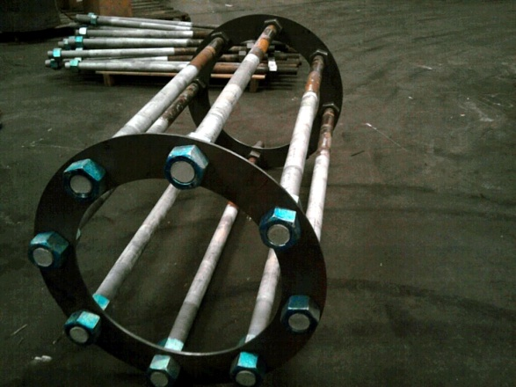
Atlantic Bolt, Inc.
4112 Pine Grove Circle
Charlotte, NC 28206
704-597-5082
704-597-1741 fax
sales@atlanticboltinc.com

