Atlantic Bolt, Inc.
4112 Pine Grove Circle
Charlotte, NC 28206
704-597-5082
704-597-1741 fax
sales@atlanticboltinc.com

Atlantic Bolt specializes in all types of concrete anchor bolts.
We are an experienced wholesale distributor and manufacturer of anchor bolts for the commercial construction industry. Atlantic Bolt has provided anchor bolts for the construction industry for over 25 years. Visit our home page to find out more about our company.
The term anchor bolts is sometimes used for many types of concrete anchors. Some are actually looking for expansion anchors, like wedge anchors or sleeve anchors, when they use the term anchor bolts. Ideally, anchor bolts are anchoring rods poured in place in concrete. Other anchoring devices used in cured concrete actually fall into the category of expansion anchors, screw in, or epoxy/chemical anchors.
First lets look at "true" anchor bolts, those poured in place. Most anchor bolts in this category are specified as ASTM F1554 grade 36, grade 55 or grade 105. L shaped, bent anchor bolts have long been the standard in this category. Atlantic Bolt carries stock on the most common sizes of bent anchor bolts. In recent years, straight or headed anchor bolts have gained popularity because of their superior pull out resistance. These types of anchor bolts usually have a nut and or a washer on the embeded end. Straight anchor bolts are specified in a broad range of diameters and lengths, sometimes with plate washers welded. For this reason, we make these anchor bolts to order, but quick delivery is our specialty.
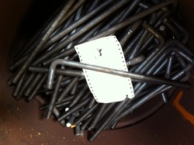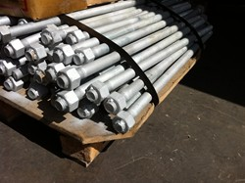
As stated before, expansion anchors are sometimes referred to as anchor bolts. When it is necessary to anchor material to cured concrete, these anchors are used and a predrilled hole is required. These types of concrete anchors utilize some type of friction mechanism to hold them in the concrete. Wedge anchors use a small wedge and are suited to solid, stable concrete. Sleeve anchors use a larger wedge that spreads the holding force over more area. For this reason they are used in concrete block, masonry, brick, mortar, or other, less solid concrete material. There are other, seldom used, types of expansion anchors, but they are rare in commercial construction and don't warrant review here.
A relatively new type of anchor bolt is the screw in type. These are basically large concrete screws, like Tapcons. Some common terms for these anchor bolts are wedge bolts, Titen anchors, high strength anchors, LDT or THD anchors. They are installed by drilling a pilot hole and driving in the screw/bolt. In some areas of the country, these anchor bolts are recognized as approved replacements or substitutes for cast in place anchor bolts in residential construction.
Chemical anchors or epoxy anchors are the last form of anchor bolts we will discuss here. As the name suggests, these anchors use some type of epoxy to anchor threaded rods into the concrete. These anchors are used in cured concrete and sometimes in block locations. When cast in place anchor bolts have been set incorrectly, chemical anchors are widely used to solve the problem.
Whether you are looking for bent anchor bolts, headed anchor bolts, anchor bolts with plate washers, or any of the anchors mentioned above, Atlantic Bolt can help you.
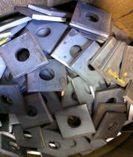
Atlantic Bolt, Inc.
4112 Pine Grove Circle
Charlotte, NC 28206
704-597-5082
704-597-1741 fax
sales@atlanticboltinc.com

<img src="http://www.webtraxs.com/webtraxs.php?id=atlanticboltinc&st=img" alt="">

