Atlantic Bolt, Inc
4112 Pine Grove Circle
Charlotte, NC 28206
704-597-5082
704-597-1741 fax
sales@atlanticboltinc.com

Sag rods, hanger rods, tension rods
Atlantic Bolt makes all types of rod assemblies to order.
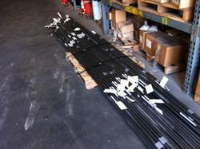
We can furnish the complete rod assembly from rods, to clevises, turnbuckles, hillside washers and, of course nuts and washers. Atlantic Bolt can supply hanger rods for everything from HVAC or sprinkler systems, to sag rods/tension rods for miscellaneous structural and canopy support.
Rods can be provided in a variety of materials and finishes. F1554 grades in plain and galvanized are available as well as stainless and others. Send us a drawing and we'll be glad to quote your projects.

See our other products
<img src="http://www.webtraxs.com/webtraxs.php?id=atlanticboltinc&st=img" alt="">

